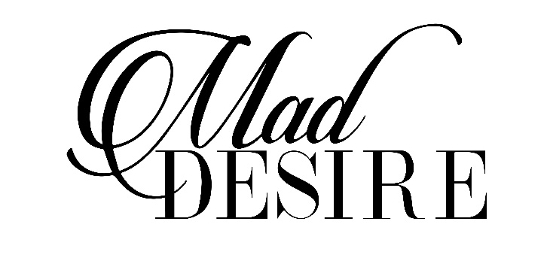

*Owner: Johanna Downs*

*Yorba Linda, CA*

|  |  |
| --- | --- |
| **Breeding Season:** | **2023** |
|  |  |
| **Mare Owners Name:** | _________________________________________ |
|  |  |
| **Owners Address:** | _________________________________________ |
|  | _________________________________________ |
|  |  |
| **Phone Number:** | _________________________________________ |
| **Cell:** | _________________________________________ |
| **E-Mail:** | _________________________________________ |
| **Mares Registered Name:** | _________________________________________ |
| **Breed Registry:** | _________________________________________ |
| **Registration Number:** | _________________________________________ |
| **Stallion Name to be bred to:** | **MAD DESIRE** |
| **METHOD OF SHIPPING** | |
|  |  |
| **FedEx $350** | _________________________________________ |
| **Counter to Counter $400  American & Delta Airlines:** | _________________________________________  _________________________________________ |
|  |  |
| **Shipping Address:** | _________________________________________ |
|  | _________________________________________ |
|  |  |
| **Stallion Stud Fee to be paid in full, accompanied by Stallion Service contract fully completed with correct information prior to first request for shipments.** | |
| **Shipping & Collection fee of $350.00 to be paid in full prior to first shipment.** | |
| This certifies that _____________________________________ (herein referred to as “**Mare Owner**”) has engaged one service for the stallion________________________________ standing at CNC SHOW HORSES via JOHANNA DOWNS (herein referred to as “**Stallion Managers**”). This contract is subject to the following conditions for the breeding season of 2023.  Once shipment leaves Stallion Managers, Stallion Managers is not responsible for loss or delay of shipment due to issues with FedEx or other methods of shipment. | |
| **Agreed upon Stud Fee:** | $______________________ |
| **Total Fees:** | $______________________ as of January 1, 2023 |
| **Registered Name of Mare:** | ______________________________________ |
| **Registered Number:** | ______________________________________ |
| **Breed:** | ______________________________________ |
| **Re-breed Contract:** | ______________________________________ |
| **Stud Fee** | ______________________________________ |

* The Stud Fee includes a non-refundable booking fee of $250.00, payable with this contract. The stud fee balance of which must be paid in full before first shipment, unless otherwise agreed upon, not applicable with re-breed contracts.
* Mare Owners have the option to pay all at once or in large non-refundable annual sums leading up to first shipment.

1. **TRANSPORTED COOL SHIPPED SEMEN**.
   1. A Semen shipping container will be provided by the Stallion Manager. Permanent containers must be returned within 72 hours of receiving semen or Mare Owners will be subject to be charged $50.00/day until returned. Any loss of equipment within the permanent containers will be charged to the mare owner. Care must be taken to properly close and secure containers. Disposable containers may also be used. Cost of disposable containers will be charged to the mare owner unless returned to Stallion Managers. All attempts will be made by the Stallion Manager to help correct any problem.
   2. **Shipping fee must be paid in full before any semen shipment is made**.
      1. A copy of the mares papers must be provided by the Mare Owner. Each shipment will be based on FedEx overnight weekday or Saturday delivery. Other methods of delivery will be priced upon request. IE Counter – counter, bus. The Mare Owner is responsible for a Shipping Fee of $350.00 per shipment and all shipping charges.
      2. Time is needed to coordinate the collection of the stallion and time of shipment. Semen requests are to be made the day before semen is needed. We do our best to accommodate all requests within reason. In the event that not enough semen is collected to meet a days’ breeding and shipping needs, on farm mare will have first priority. Shipped semen requests will be filled in the order received. Stallion Managers agree to provide two (2) doses of semen per shipment. Stallion agent guarantees live foal from the breeding contracted herein. Live foal is defined as a foal that stands and nurses without assistance. Should the mare prove not to be in foal, aborts or should the foal not stand and nurse without assistance, Mare Owner shall notify in writing within one (1) week of the foaling date. Such a statement should be accompanied by a written statement from a licensed veterinarian verifying that the foal is not “live” as defined above.
      3. Under the foregoing circumstances, the Stallion Manager shall give the Mare Owner a free season for the following year. There can be a substitute mare in place of the originally bred mare for re-breeding the following year. With the attempts of rebreeding, then any and all fees paid shall not be refundable, the right to rebreed is thereby cancelled and the Stallion Manager is released from any further obligation.
      4. A Breeder’s Certificate will be issued for the foal, conceived by this mating, when all stallion fees and all other expenses (including vets) are paid in full, when mare has produced a live foal by the mating.
      5. It is further agreed that should the stallion die, be sold by the owner, or become unfit for service prior to settling the mare, that the Stud Fee less the booking fee and expenses owed will be refunded, if it has been paid in full. This thereby cancels the entire contract. If mare dies or becomes unfit before being pronounced safe in foal, the Stallion Manager has the option to accept another mare as a replacement, or a return for the following season.
      6. This contract is non-assignable and non-transferable.
      7. This contract is entered into the State of California, and will be interpreted and enforced under the laws of California. If any clause in the contract is against California law, there that clause shall be null and void.
      8. This contract represents the entire agreement between the parties. No other agreements, promises, verbal or implied are included unless specifically stated in this written contract.

|  |  |
| --- | --- |
| **Mare Owners or authorized agent signature:** | ______________________________________________ |
|  |  |
|  |  |
|  |  |
| **Stallion Manager’s Signature:** | ______________________________________________ |
| **Write checks out to:** | Johanna Downs |
| **Mail Contracts and Payment:** | Johanna Downs  3610 Fairmont Blvd.  Yorba Linda, CA 92886 |
| **MAKE ALL BREEDING & SHIPPED SEMEN REQUESTS WITH:** | **Brooke Nguyendo @ 951-442-2633**  **Cindy Polley @ (951) 743-5653** |